**CS 271 Spring 2020**

**Assignment 6**

**Student ID: 014498887**

**Name: Yash Sahasrabuddhe**

Q.1.

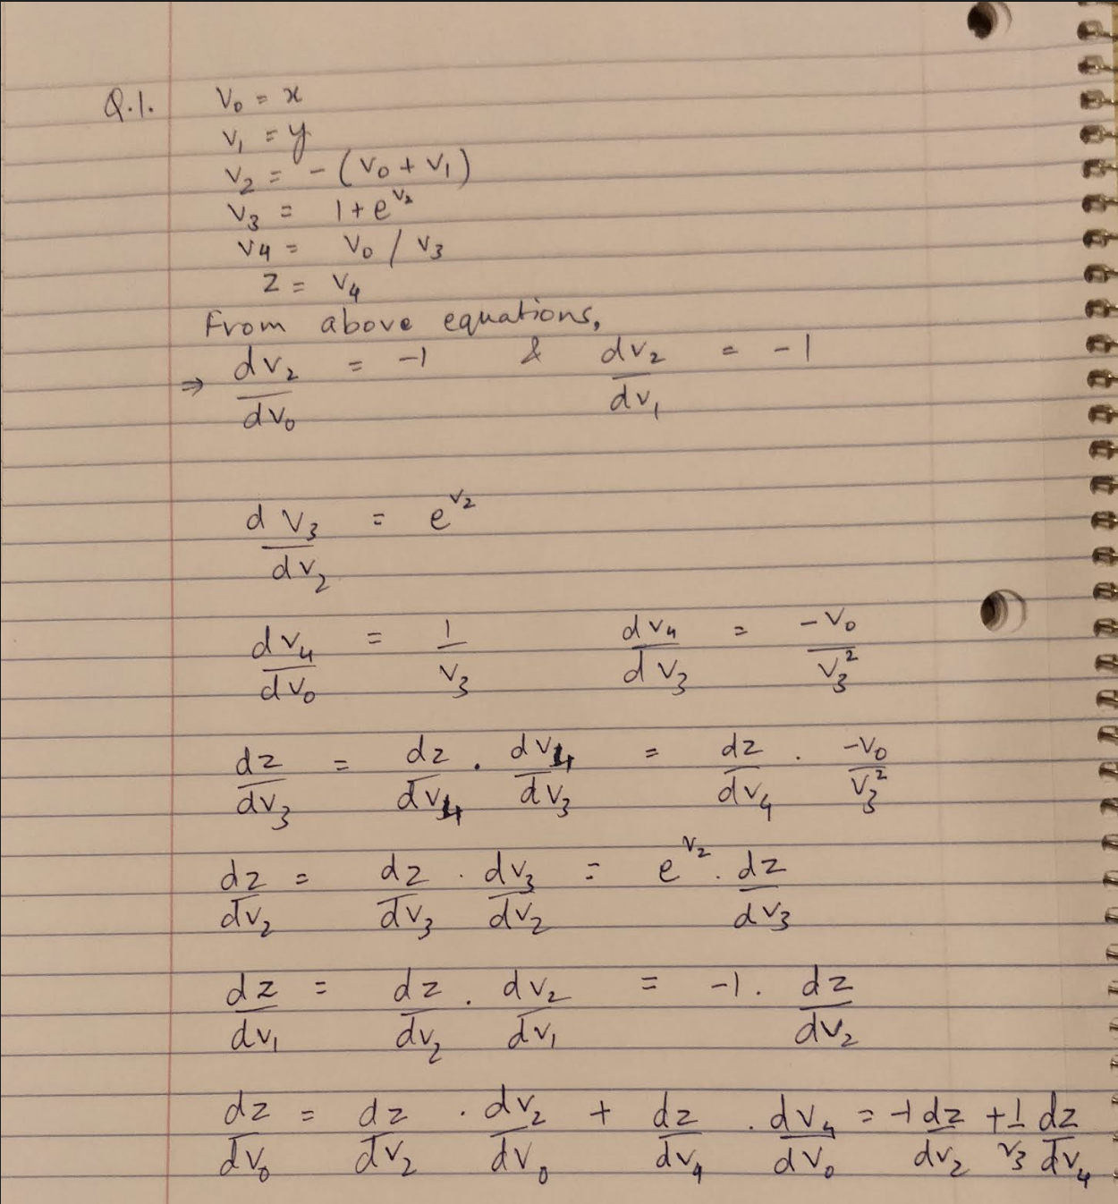

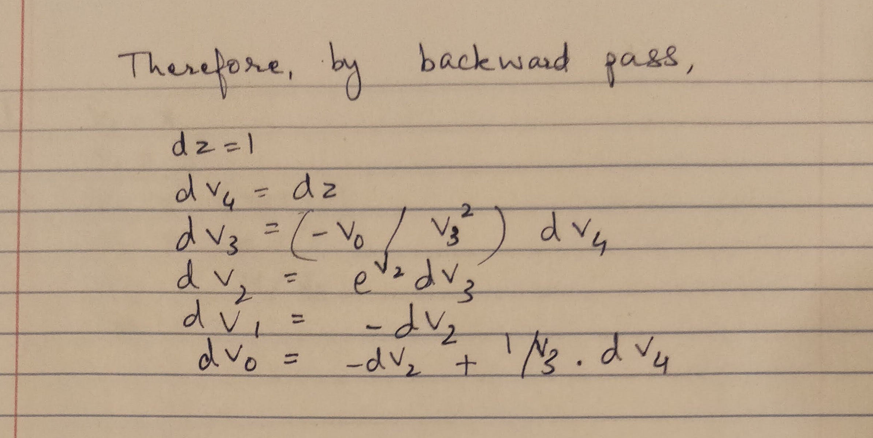

Q.2.



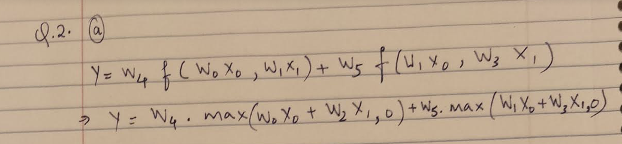



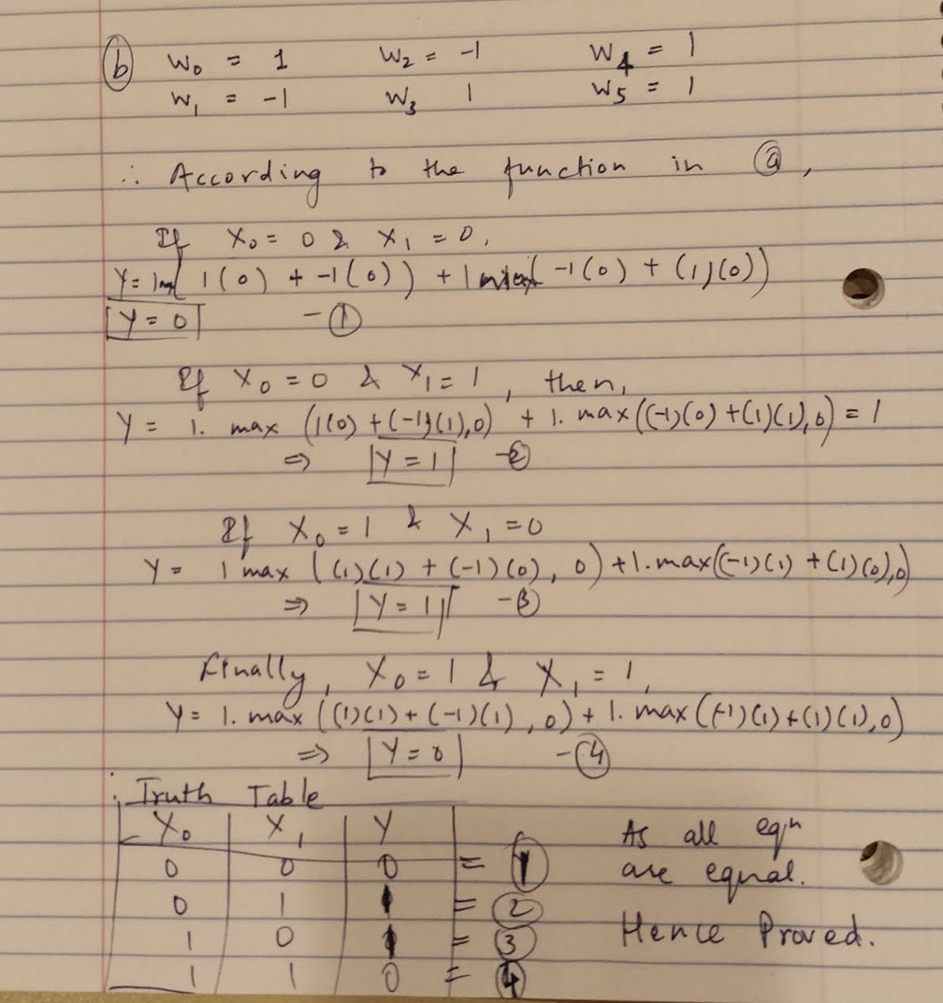

Q.4.

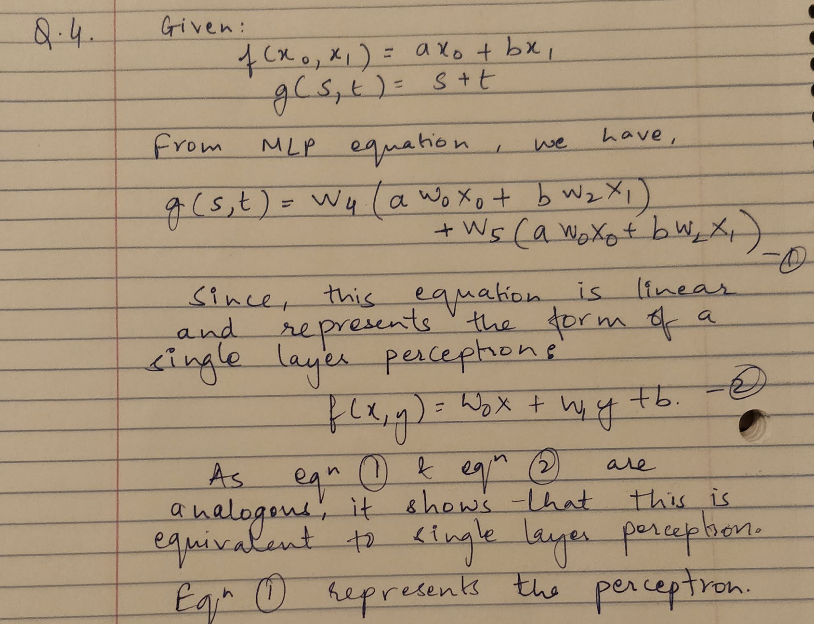

Q.6.

1. The output for this part is as below. The source code is included in the submission as Q6a.py file.

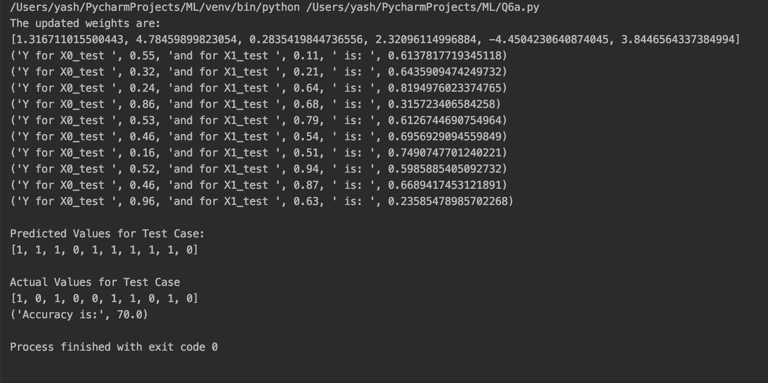

1. The output for this part is as below. The source code is included in the submission as Q6b.py file.

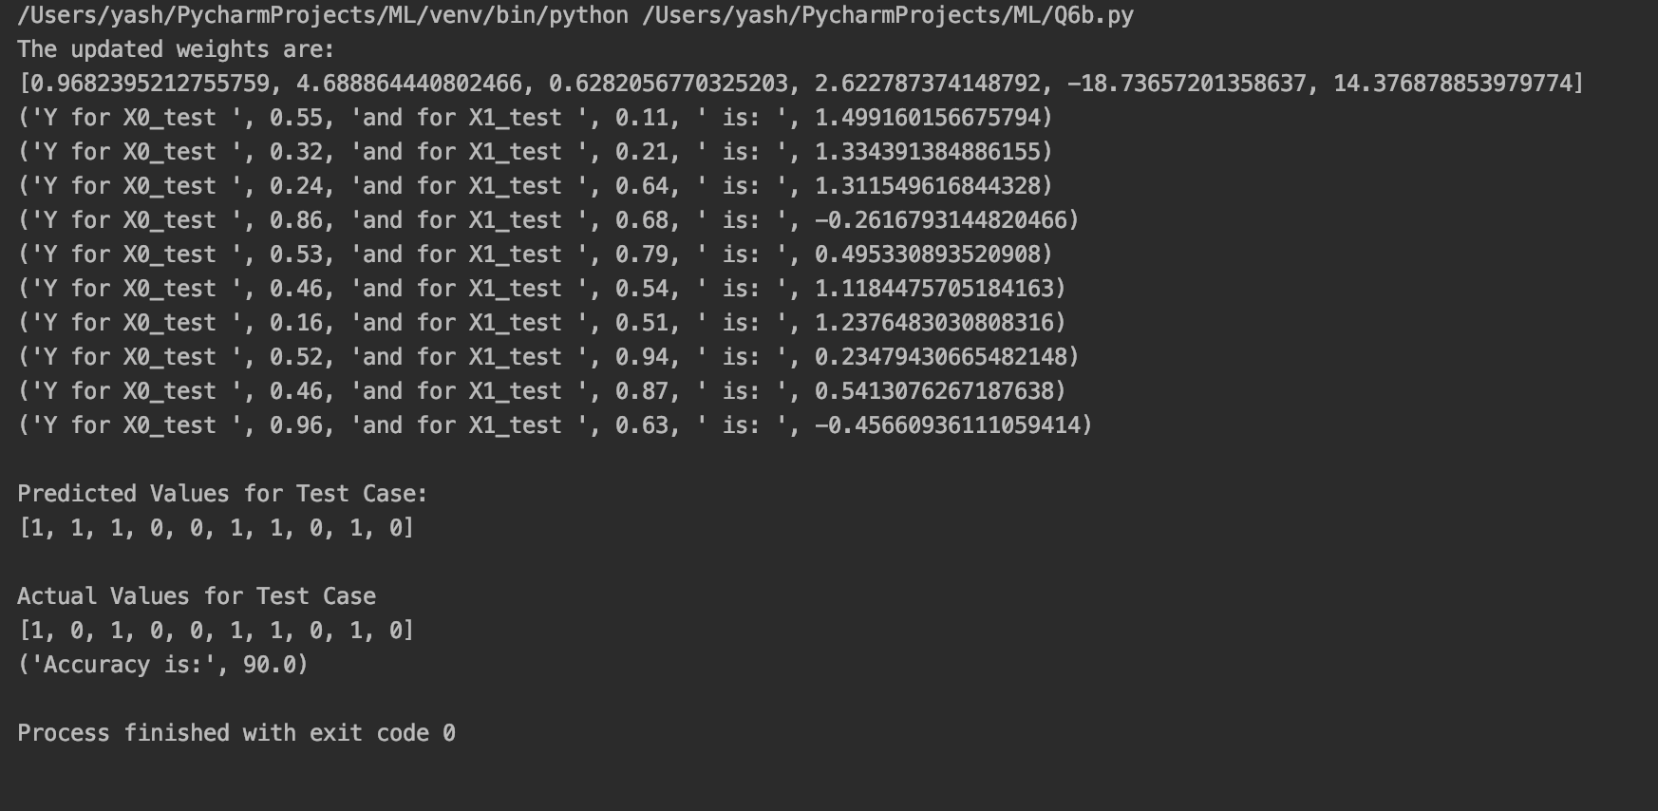

Q.8.

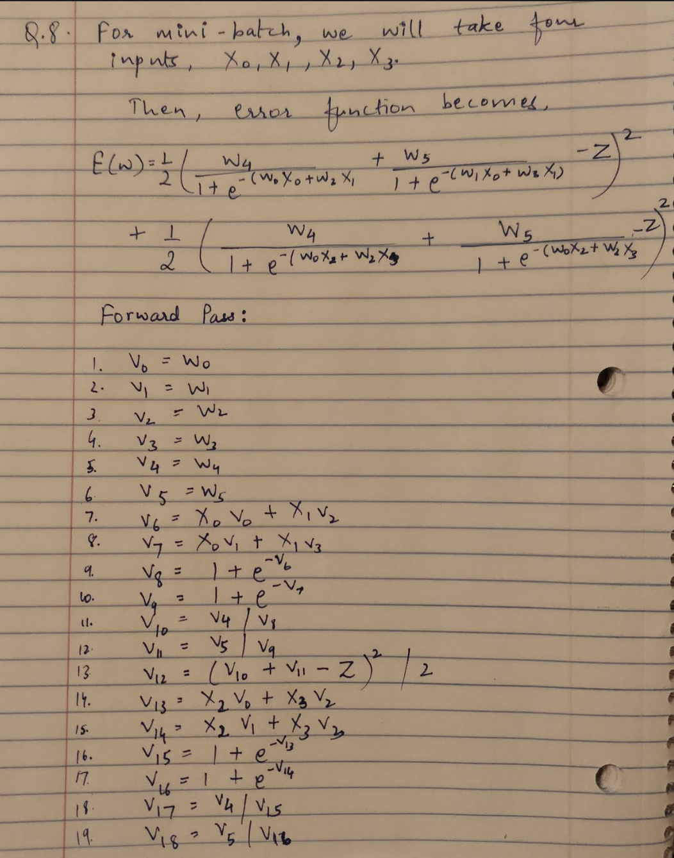

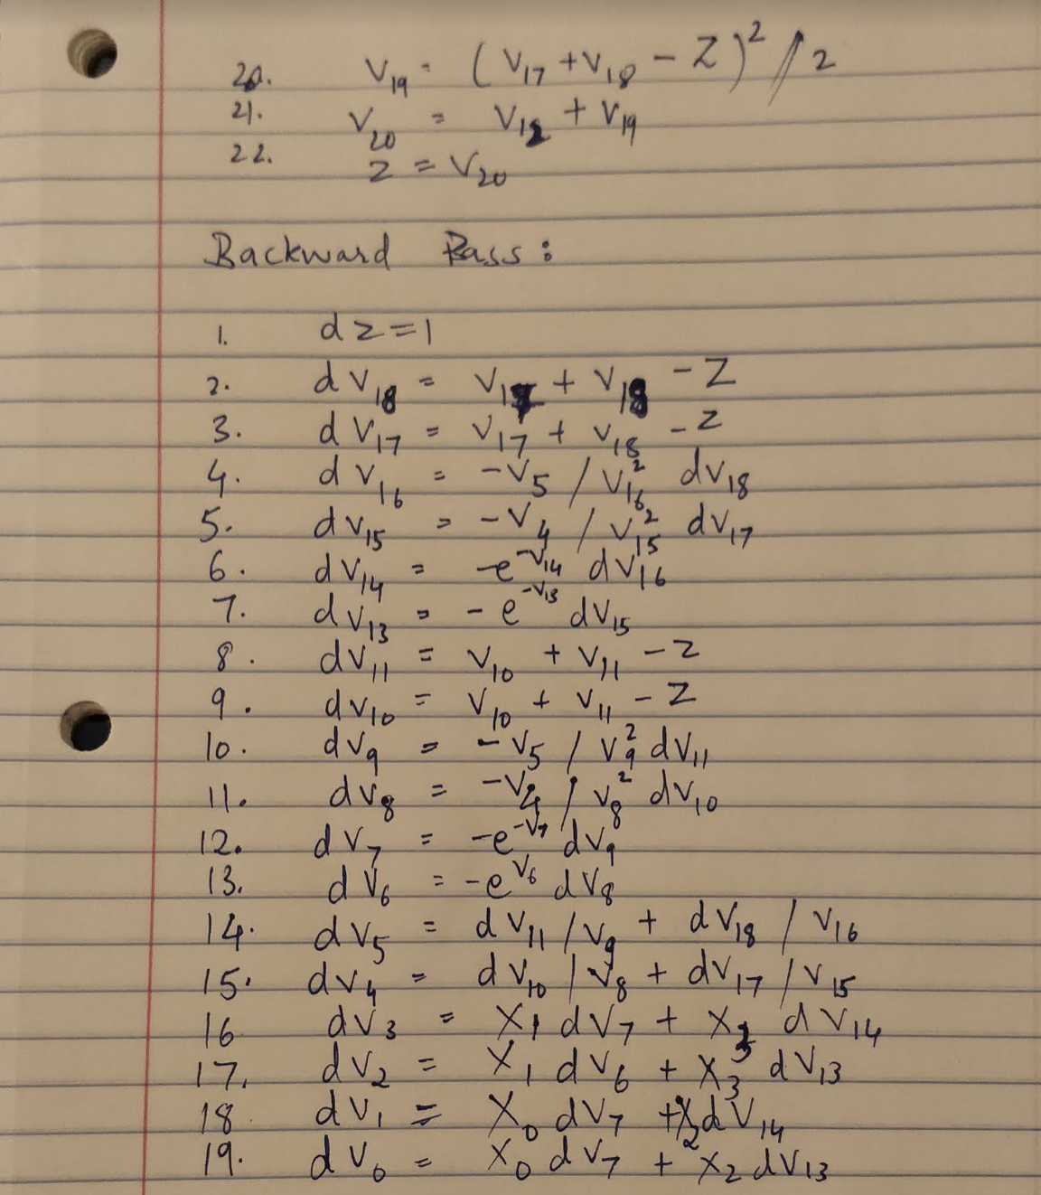

Q.10.

I have used the HMM_fast_ref code provided by the professor for this question. The files for this code can be found in the submission. The main source code is hmm.c. The final output which I got is as below:

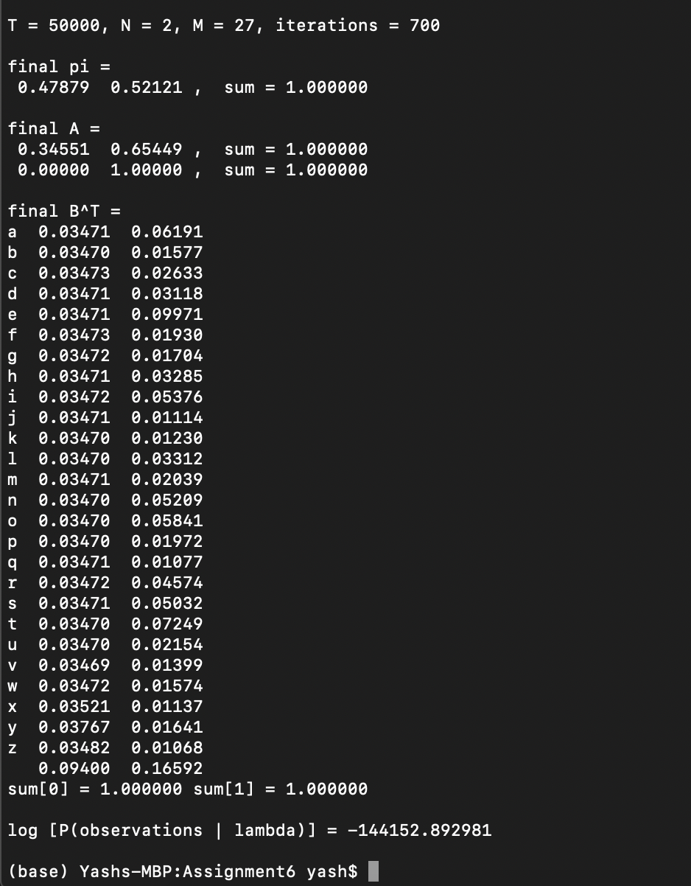

Note – I discussed the questions with Aditi Walia. No code was shared.